# Supporting Information for: Tracing the consumption origins of wastewater and sludge for a Chinese city based on waste input-output analysis

## Lishan XIAO1, Chen LIN2, Shinichiro NAKAMURA3

1 School of Environmental and Geographical Sciences, Shanghai Normal University, Shanghai, 200234, China

2 School of Applied Economics, Renmin University of China, Beijing, 100872, China

3 Faculty of Political Science and Economics, Waseda University, Tokyo 169-8050, Japan

Corresponding author, Email: [c_lin@ruc.edu.cn](mailto:c_lin@ruc.edu.cn)

**Number of pages: 22, Number of tables: 9, Number of figures: 2**

**Contents**

1 Current state of wastewater and sludge treatment in China sludge growth, laws, and policies in China S4

2 Methodology S5

2.1 The W2IO model S5

2.2 The W2IO table and other data S8

2.3 Scenario analysis S15

2.4 Sensitivity analysis S16

3 Results S17

3.1 Wastewater and sludge footprint by final demand categories S17

3.2 Direct discharge versus footprint S17

3.3 Sensitivity analysis S17

3.4 Transboundary impacts S21

References S21

**List of Figures**

Figure S1 Wastewater and sludge footprint by final demand categories ................S17

Figure S2 Direct discharge versus W2F of the largest 40 sectors...........................S17

**List of Tables**

Table S1 Framework of the W2IO table....................................................................S6

Table S2 Production sector classification: Xiamen IO table................................... S8

Table S3 The allocation matrix $S$ of waste/wastewater to treatment processes....S12

Table S4 The W2IO table of Xiamen based on the framework in Table 1............ S13

Table S5 COD and wastewater discharge..............................................................S14

Table S6 Data on food (diet, toilet discharge, and carbon content) ......................S15

Table S7 Sensitivity elasticity of pre-consumption W2F and SF to input and waste generation coefficients...........................................................................S18

Table S8 Sensitivity elasticity of post-consumption W2F and SF with respect to key parameters..............................................................................................S20

Table S9 Wastewater and sludge embodied in trade..............................................S21

## 1 The current state of wastewater and sludge treatment in China

China has the second-highest wastewater treatment capacity in the world (Zhang et al., 2016), with 5222 wastewater treatment plants to treat 2.28×108 m3 wastewater every day in 2018. The sludge in China was 11.7 million tons in 2018, with an average annual growth rate of 10% from 2011-2018. Sludge is treated by landfilling (50%), incineration (10%), materials recycling (9%), and composting (16%) (Zhang et al., 2016). Although landfills accounted for the largest part of sludge treatment, it is not a favorable solution in the future. The water content of the sludge for landfills should be less than 60% after 2007 (MOHURD, 2007). As a result, a large amount of landfilled sludge cannot meet the new requirements and thus is disposed of improperly (Yang et al, 2015). Given that 80% of landfills cannot meet the national standard, only about 45% of the sludge is properly treated at present.

Sludge for land use and incineration have been recommended as the best available technologies (MEE, 2010). Sludge treatment should be compatible with technology, economic development level, and environmental management requirement for different application conditions. Furthermore, the wasteless city plan further proposed to minimize the amount of landfills and ultimately realize the full utilization of waste (GSC, 2018). In 2020, The latest revision of the Law on the Prevention and Control of Environmental Pollution by Solid Wastes confirmed that sludge treatment facilities should be incorporated into the urban wastewater treatment plan. China is in a transition period with respect to wastewater and sludge management from end-pipe disposal to waste-to-resource management.

## 2 Methodology

### 2.1 Calculation of sludge generation

Sludge generation data in *Chinese Statistical Yearbook of Urban and Rural Construction* are collected at the city level which contain the information of each cities in China. However, WWTPs in county level are ignored. In order to obtain the data integrity, we collected the plant level sludge data from *2018 Urban Drainage Statistical Yearbook*, found its location through Baidu map API. Finally, spatial join were implemented to clarify the county where the WWTP located. Due to the lack of sludge data in plant level, we used the flow of wastewater treatment to calculate sludge generation in each plant based on its high positive correlation (Figure S1).

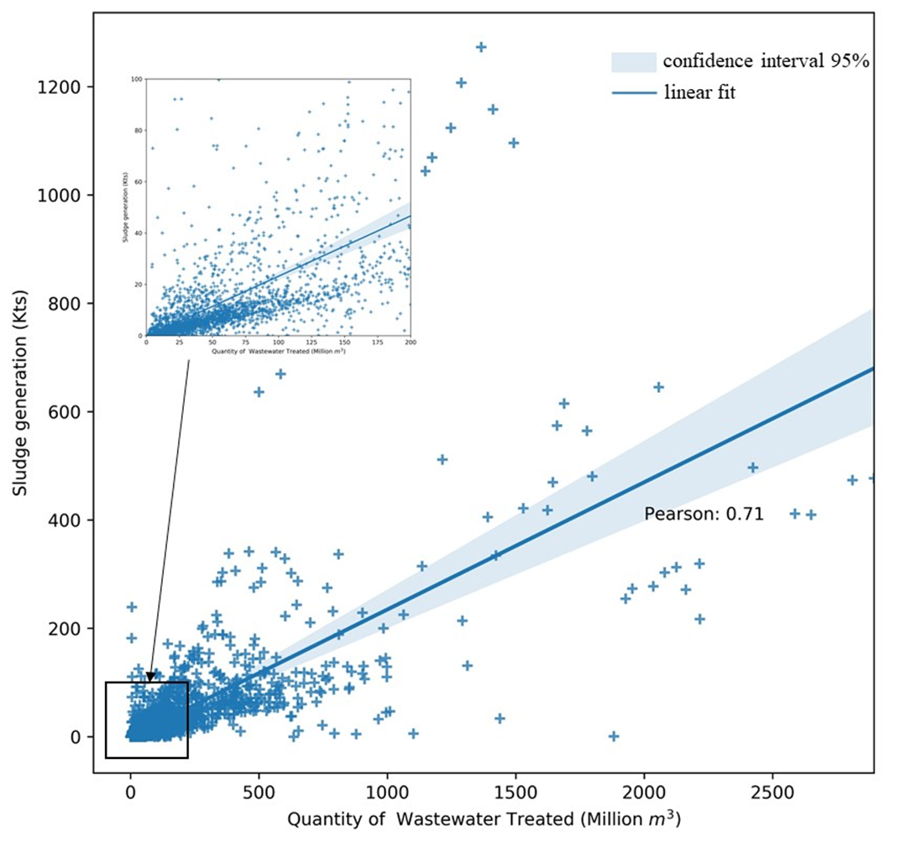

**Figure S1 Correlation between sludge generation and the quantity of wastewater treated**

The relationship between sludge generation and the quantity of wastewater treatment are given by:

$Ds=365×F×s$（S1）

Where *Ds* represents dry sludge, *F* is the flow of wastewater treatments, *s* is the conversion coefficients which are obtained from *2018 Urban Drainage Statistical Yearbook* (Tabel S1).

**Table S1 Conversion coefficients in each province**

|  |  |
| --- | --- |
| **Province** | **s (t/10 Kts)** |
| Beijing | 7.31 |
| Tianjin | 5.95 |
| Hebei | 8.26 |
| Shanxi | 7.51 |
| Inner Mongolia | 6.98 |
| Liaoning | 4.61 |
| Jilin | 4.13 |
| Heilongjiang | 5.60 |
| Shanghai | 4.56 |
| Jiangsu | 6.43 |
| Zhejiang | 9.95 |
| Anhui | 4.61 |
| Fujian | 4.01 |
| Jiangxi | 3.07 |
| Shandong | 7.85 |
| Henan | 6.55 |
| Hubei | 4.65 |
| Hunan | 3.29 |
| Guangdong | 4 |
| Guangxi | 3.37 |
| Hainan | 3.48 |
| Chongqing | 6.04 |
| Sichuan | 5.31 |
| Guizhou | 3.56 |
| Yunnan | 4.77 |
| Tibet | 2.27 |
| Shaanxi | 7.83 |
| Gansu | 9.92 |
| Qinghai | 6.22 |
| Ningxia | 7.55 |
| Xinjiang | 7.91 |

### Scenario analysis

Two scenarios were considered to assess the effects of possible changes in industrial structure and diet patterns. The first one (Scenario 1) is based on the rate of industrial growth prescribed in the 13th Five-Year Plan for economic and social development in Xiamen city. In that plan, sectors such as electronic information and mechanical manufacturing are expected to play a vital role in economic growth, with the output of electronic information expected to increase from 0.3 trillion RMB in 2015 to 0.7 trillion RMB in 2020, or a 2.3-fold increase. To assess the impacts of planned industrial growth, we evaluated the effects on wastewater and sludge of the same 2.3-fold increase in the final demand for the products of 15 manufacturing sectors consisting of cars, ships, machinery, electronics, computer, and communication equipment. Denoting by ${DW}_{S1}$, ${W2F}_{S1}$, and ${W2F}_{S1}$ the direct wastewater discharge, wastewater footprint, and sludge footprint under Scenario 1, respectively, we have

${DW}_{S1}=\sum_{i}{r_{i}×{DW}_{i}}$ (S11)

${W2F}_{S1}=\sum_{i}{r_{i}×{W2F}_{i} }$ (S12)

${SF}_{S1}=\sum_{i}{r_{i}×{SF}_{i} }$ (S13)

where $r_{i}$ refers to the expected rate of change in the output of sector *i*.

The second scenario (Scenario 2) refers to a possible shift in diet from the traditional Chinese one mostly based on staples toward a European (Spanish) one involving larger amounts of animal-sourced foods. The evaluation was carried out by altering the consumption of "Vegetable oil and forage” “Slaughtering and meat processing”, “Prepared fish and seafood”, “Vegetable, fruit and nut processing,” and “Liquid milk and dairy products” to the Spanish level (the last column of Table S3), and applying the same calculation as in Scenario 1.

### Sensitivity analysis

To examine the robustness of the results, we conducted a sensitivity analysis for key parameters based on the sensitivity elasticity of parameters (Heijungs and Lenzen, 2014; Lin et, al., 2020), which indicates the ratio by which a change in “key parameters” changes the results, W2F and SF in our case. The elasticity is given by

$EL=\frac{∂y}{∂a}× \frac{a}{y}$ (S14)

where $y$ denotes W2F or SF and $a$ the parameter under study. Among others, $θ_{i}$ and $α_{j}$ are considered as key parameters.

## 3 Results

### 3.1 Direct discharge versus footprint

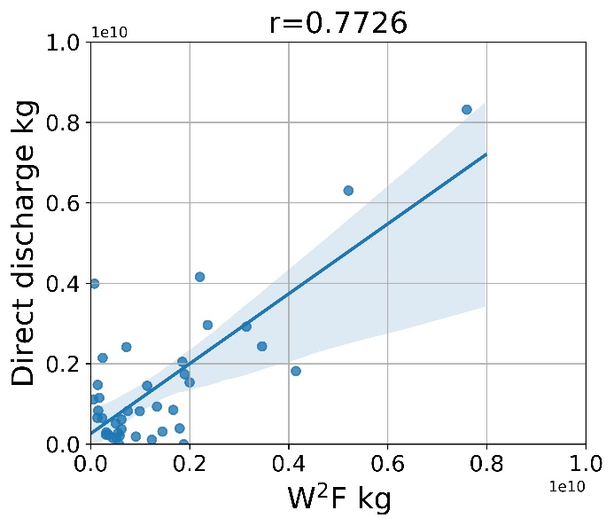

**Figure S1 Direct discharge versus W2F of the largest 40 sector**

### 3.2 Wastewater and sludge footprint by final demand categories

In terms of final demand categories, the largest share of W2F (42%) is attributed to export, followed by urban household consumption (33%). The largest share of SF (78%) is attributed to urban household consumption, followed by export (10%) (Figure S2).

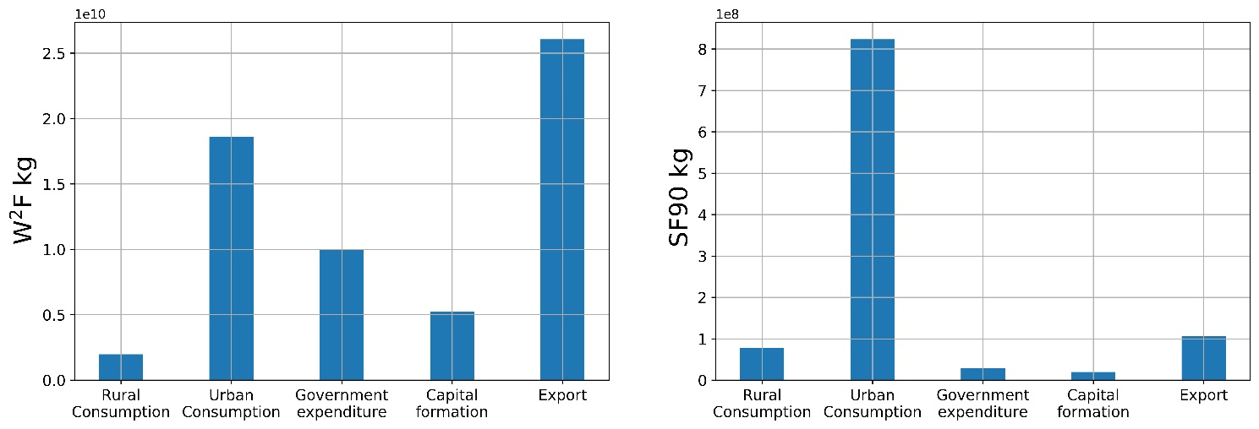

**Figure S2 Wastewater and sludge footprint by final demand categories**

### 3.3 Sensitivity analysis

#### 3.3.1 The sensitivity of pre-consumption W2F and SF to input and waste generation coefficients

Table S7 shows input and wastewater generation coefficients elasticities of pre-consumption W2F and SF, and gives the ratio by which a change in relevant coefficients changes W2F or SF. For instance, the value 0.000003 at the upper-left cell shows that a one % change in the input coefficient of electricity of the composting process changes the wastewater footprint by 0.000003, that is, practically no impact. The results indicate that for most cases the elasticities are small, with the occurrence of large elasticities concentrated to sludge generation coefficients. The largest one, 2.77, refers to the effects on sludge80 footprint of the sludge90 generation coefficients of Dew80, Dew60, landfill, and incineration treatment processes. It implies that a one % change in the coefficient change would induce a 2.77% change in SF of sludge80. Since these coefficients were directly obtained from data on the real operation of WWTPs in the city, they are of high reliability, implying the robustness of our results of SF.

**Table S7 Sensitivity elasticity of** **pre-consumption W2F and SF to input and waste generation coefficients**

|  |  |  |  |  |  |
| --- | --- | --- | --- | --- | --- |
| Footprint  Coefficients | | Wastewater | Sludge90 | Sludge80 | Sludge60 |
|  | Compost | 0.000003 | 0.000000 | 0.000002 | 0.000001 |
|  | A2O | 0.000037 | 0.000000 | 0.000029 | 0.000011 |
|  | OD | 0.000082 | 0.000000 | 0.000066 | 0.000024 |
| Electricity | BF | 0.000068 | 0.000000 | 0.000055 | 0.000020 |
|  | Dew80 | 0.000002 | 0.000000 | 0.000002 | 0.000001 |
|  | Dew60 | 0.000004 | 0.000000 | 0.000003 | 0.000001 |
|  | Landfill | 0.000000 | 0.000000 | 0.000000 | 0.000000 |
|  | Incineration | 0.000002 | 0.000000 | 0.000001 | 0.000001 |
|  | Compost | 0.000000 | 0.000000 | 0.000000 | 0.000000 |
|  | A2O | 0.000000 | 0.000000 | 0.000000 | 0.000000 |
|  | OD | 0.000000 | 0.000000 | 0.000000 | 0.000000 |
| Wastewater | BF | 0.000000 | 0.000000 | 0.000000 | 0.000000 |
|  | Dew80 | 0.000000 | 0.000000 | 0.000000 | 0.000000 |
|  | Dew60 | 0.000000 | 0.000000 | 0.000000 | 0.000000 |
|  | Landfill | 0.000280 | 0.000000 | 0.000000 | 0.000000 |
|  | Incineration | 0.000280 | 0.000000 | 0.000227 | 0.000082 |
|  | Compost | 0.000000 | 0.000000 | 0.000000 | 0.000000 |
|  | A2O | 0.000000 | 0.192764 | 0.000000 | 0.000000 |
|  | OD | 0.000062 | 0.481927 | 0.534416 | 0.192783 |
| Sludge90 | BF | 0.000216 | 0.325310 | 1.870517 | 0.674760 |
|  | Dew80 | 0.000321 | 0.000000 | 2.772421 | 1.000108 |
|  | Dew60 | 0.000321 | 0.000000 | 2.772421 | 1.000108 |
|  | Landfill | 0.000321 | 0.000000 | 2.772421 | 1.000108 |
|  | Incineration | 0.000321 | 0.000000 | 2.772421 | 1.000108 |
|  | Compost | 0.000000 | 0.000000 | -1.772122 | 0.000000 |
|  | A2O | -0.000026 | 0.000000 | -1.772143 | -0.000007 |
|  | OD | -0.000026 | 0.000000 | -1.772143 | -0.000007 |
| Sludge80 | BF | -0.000026 | 0.000000 | -1.772143 | -0.000007 |
|  | Dew80 | -0.000026 | 0.000000 | 0.999976 | -0.000007 |
|  | Dew60 | 0.000015 | 0.000000 | 1.000013 | 0.000004 |
|  | Landfill | 0.000015 | 0.000000 | 1.000013 | 0.000004 |
|  | Incineration | 0.000015 | 0.000000 | 1.000013 | 0.000004 |
|  | Compost | 0.000000 | 0.000000 | 0.000000 | 0.000000 |
|  | A2O | 0.000000 | 0.000000 | 0.000000 | 0.000000 |
|  | OD | 0.000000 | 0.000000 | 0.000000 | 0.000000 |
| Sludge60 | BF | 0.000000 | 0.000000 | 0.000000 | 0.000000 |
|  | Dew80 | 0.000000 | 0.000000 | 0.000000 | 0.000000 |
|  | Dew60 | 0.000000 | 0.000000 | 0.000000 | 1.000000 |
|  | Landfill | 0.000267 | 0.000000 | 0.000217 | 1.000090 |
|  | Incineration | 0.000267 | 0.000000 | 0.000217 | 1.000090 |

Note: The first and second columns show the names of input and waste generation coefficient. The first row show the names of wastewater and sludge footprints.

#### 3.3.2 The sensitivity of post-consumption W2F and SF to key parameters

Table S8 shows the sensitivity elasticities of post-consumption W2F and SF to key parameters, $θ_{i}$ and $α_{j}$. The first block shows the effects of a change in the discharge rate of toilet water associated with the excretion of food item *i*, that is, $θ_{i}$, on post-consumption WWF. For instance, the value 0.12 of the upper-left cell indicates that a one percent change in the amount of discharge of toilet water associated with the excretion of grain mill products results in a 0.12% change in the amount of post-consumption W2F. The results indicate that the elasticities are rather small, with none exceeding 0.6. The largest value is observed for "Vegetable, fruits, and nut processing” on post SF, because of its largest share (53%) in the total mass food consumption.

The second block of Table S7 shows the impacts of a change in the ratio of raw sludge to total COD, $α_{j}$, of the three WWTPs on the amount of post-consumption W2F. The results indicate that the amount of post-consumption W2F is relatively sensitive to the parameter of OD treatment, which can be explained by that its treatment capacity is larger than the other two treatment processes. The parameter is obtained from annual WWTPs operation data in the city and hence is of high credibility, implying the robustness of our post-consumption SF results.

**Table S8 Sensitivity elasticity of post-consumption W2F and SF with respect to key parameters**

|  |  |  |  |
| --- | --- | --- | --- |
| Footprint  Parameters | | Wastewater | Sludge90 |
|  | Grain mill products | 0.12 |  |
|  | Vegetable oil and forage | 0.03 |  |
|  | Slaughtering and meat processing | 0.15 |  |
|  | Prepared fish and seafood | 0.06 |  |
| $$θ_{i}$$ | Vegetable, fruit and nut processing | 0.54 |  |
|  | Liquid milk and dairy products | 0.05 |  |
|  | Other food manufacturing | 0.02 |  |
|  | Wines, spirits and liquors | 0.02 |  |
|  | Non-alcoholic beverage | 0.01 |  |
|  | A2O |  | 0.19 |
| $$α_{j}$$ | OD |  | 0.48 |
|  | BF |  | 0.33 |

Note: The first and second columns show the parameters. The first row show the names of wastewater technology and sludge footprints.

### 3.4 Transboundary impacts

In the literature on carbon footprint based on multi-regional input-output (MRIO) analysis it is common to look at the impacts embodied in trade. While the current IO data is a single region one, it is possible to estimate the amounts of wastewater and sludge embodied in trade, assuming that the technology of the exporting countries is the same as that of Xiamen, that is, $\hat{m}=0$ in (S10). The results in Table S9 indicate that Xiamen is a net exporter of wastewater and sludge, although the extent of “trade surplus” for the latter is much smaller. It is not the case that the city is keeping its own water resources clean at the expense of other regions of China.

**Table S9 Wastewater and sludge embodied in trade**

|  |  |  |
| --- | --- | --- |
|  | Embodied in export | Embodied in import |
| Wastewater (107 kg) | 6778 | 5813 |
| Sludge90 (103 kg) | 291741 | 274283 |

## References

CCNPS (Compilation Committee for National Pollution Survey). Household Discharge Coefficient and Use Instructions. China Environmental Science Press. 2011.(in Chinese)

GSC (General Office of the State Council). Pilot Work Plan for the Construction of Wasteless Cities. 2018. In Chinese.

Heijungs R and Lenzen M. Error propagation methods for LCA - a comparison. International Journal of Life Cycle Assessment. 2014, 19(7): 1445-1461.

Henze M, Harremoës P, Jansen J, Arvin E. Wastewater treatment. Biological and chemical processes. 3rd ed. Berlin, Springer, 2002.

JWRC. Japan Water Research Center. <http://www.jwrc-net.or.jp/map/shiyouryou_map.html>. (In Japanese).

Lin C, Qi J, Liang S, Feng C, Wiedmann T, Liao Y, Yang X, Li Y, Mi Z, Yang Z. Saving less in China facilitates global CO2 mitigation. Nature Communications. 2020, 11: 1-12.

MEE . Guideline on Best Available Technologies of Pollution Prevention and Control for Treatment and Disposal of Sludge from Municipal Wastewater Treatment Plant. 2010. In Chinese.

Miller RE, Blair PD. Input-output analysis: Foundations and Extensions. UK, Cambridge University Press.2009

MOHURD (Ministry of Housing and Urban-Rural Development of People’s Republic of China), 2007. The disposal of Sludge from Municipal Wastewater Treatment Plant-Sludge Quality for Co-landfilling (CJ/T 249-2007). (In Chinese)

Munoz I, Canals L, Clift R. Consider a Spherical Man. Journal of Industrial Ecology. 2008, 12: 521-537.

Nakamura S and Kondo Y. Input-Output Analysis of Waste Management. Journal of Industrial Ecology. 2002, 6(1): 39–63.

Nakamura S and Kondo Y. Waste Input-Output Analysis: Concepts and Application to Industrial Ecology. Springer. 2009.

Nakamura S and  Nansai K. “Input–output and hybrid LCA,” in *Special types of life cycle assessment*, Ed.M. Finkbeiner Springer, 2016.

XEPB (Xiamen Environmental Protection Bureau). Xiamen Annual Environmental statistics report. 2012.(In Chinese)

XPSO(Xiamen Pollution Survey Office). Technical report of the pollution Survey in Xiamen City, Fujian Province. 2011.

XSB (Xiamen Statistic Bureau). Xiamen Input-Output Table. 2012. (In Chinese)

XSB (Xiamen Statistic Bureau). Yearbook of Xiamen Special Economic Zone. 2013. <http://202.109.255.156:8130/files_pub/publish/2013/2013/main0.htm>. (In Chinese)

Yan Z, Cui S, Li G, Ren Y, Dynamics and Environmental Load of Food Carbon Consumption During Urbanization: A Case Study of Xiamen City，China. Environmental Science. 2013, 34(4): 1636-1644. (In Chinese)

Yang G, Zhang G, Wang H. Current state of sludge production, management, treatment and disposal in China. Water Research, 2015, 78: 60-73.